Mathematics


Items highlighted in yellow are tasks for you to complete
Items in Blue italics are help tips

Multiply by 9
This one is simple – to multiple any number between 1 and 9 by 9 hold both hands in front of your face – drop the finger that corresponds to the number you are multiplying (for example 9×3 – drop your third finger) – count the fingers before the dropped finger (in the case of 9×3 it is 2) then count the numbers after (in this case 7) – the answer is 27.

Finger Math: 9X Rule

To multiply by 9, try this: 9 x 3
(1) Spread your two hands out and place them on a desk or table in front of you.
(2) To multiply by 3, fold down the 3rd finger from the left. To multiply by 4, it would be the 4th finger and so on. 9 x 3 = 3rd finger left leave 2 fingers and to the right seven fingers so write 2 and 7 = 27
(3) the answer is 27 ... READ it from the two fingers on the left of the folded down finger and the 7 fingers on the right of it.
This works for anything up to 9 x 10!

9 x 5 sample

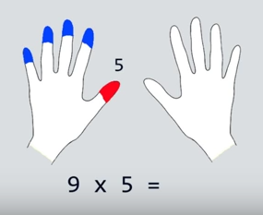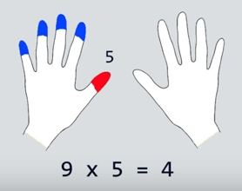
Find 5th digit left hand Counting left = 4
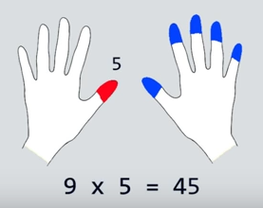
Counting right we have 5 so insert the 5 answer 45


Need help just ask

